Title
ABSTRACT 8-15 lines in "Abstract" style, with simple space.
Keywords list of 3-5 keywords separated with commas
I. INTRODUCTION
Files must be in MS Word or in Latex (using dedicated template). Figures and tables should be embedded and not supplied separately. For paragraph text, use “Paragraph” style (Palatino Linotype, 10). Please make sure that you use as much as possible normal fonts in your documents.
Please do not alter the formatting and style layouts, which have been set up in this template document. All the required style templates are provided in the file “Template AJCE” with the appropriate name supplied.
This journal uses double-blind review, which means that both the reviewer and author identities are concealed from the reviewers, and vice versa, throughout the review process. Authors need to ensure that their manuscripts are prepared in a way that does not give away their identity. The authors have to submit separately the “Title Page” containing the Authors details and Anonymized Manuscript with no author details as 2 separate files (templates dedicated to these two files are provided). In the manuscript, remove any identifying information, including author names and ensure document properties are also anonymized, use the third person to refer to work the Authors have previously undertaken, make sure figures do not contain any affiliation related identifier, remove references to funding sources and do not include acknowledgments.
II. FORMAT
A. List and Equations
When Bulleted lists may be included and should look like this:
- First point
- Second point
- And so on
Numbered lists use this format:
- First point
- Second point
- And so on
Equations and formulae should be typed in Mathtype, and numbered consecutively with Arabic numerals in parentheses on the right hand side of the page (if referred to explicitly in the text). They should also be separated from the surrounding text by one space.
B. Table and Figure
All tables should be numbered with Arabic numerals. Every table should have a caption. Headings should be placed above tables. Tables must be embedded into the text and not supplied separately. Let a line space below the table. Table 1 is an example of a table.
TABLE 1. Example
Example | Column A | Column B
Line A | 1 | 1
Line B | 2 | 2
Line C | 3 | 3

All figures should be numbered with Arabic numerals (1,2,3…). Every figure should have a caption. Figures must be embedded into the text and not supplied separately. Please ensure that all the figures are of 300 DPI resolutions (minimum). The figure number and caption should be typed below the illustration. Let a line space below the figure. For example, see Fig. 1.

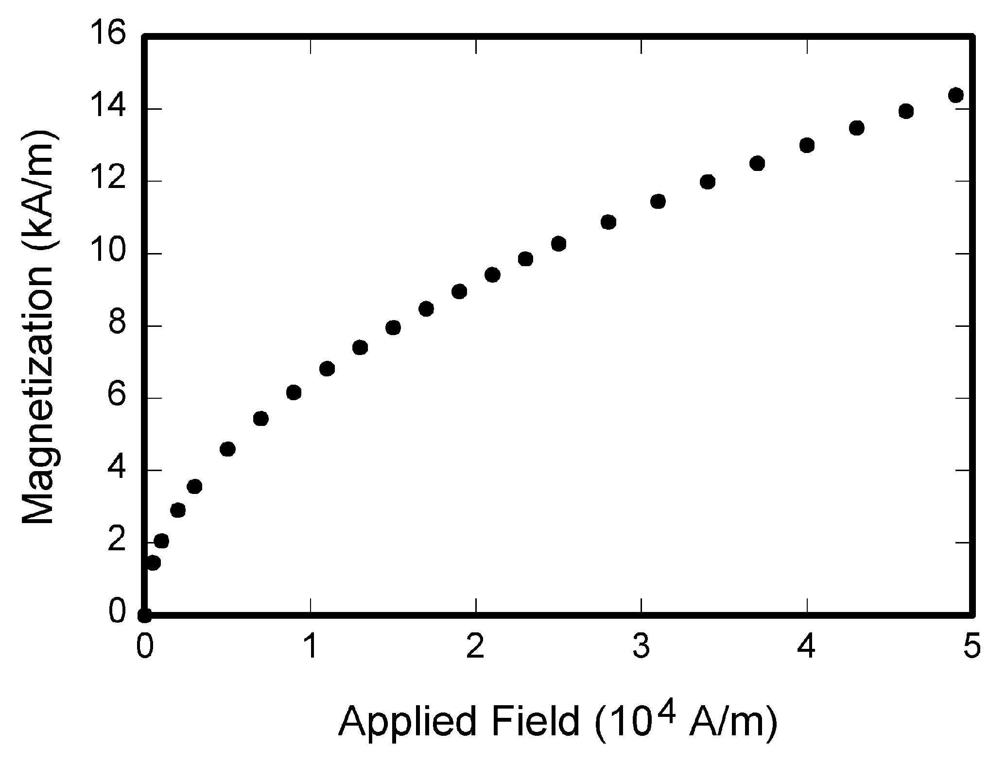
FIGURE 1. Example

REFERENCES
Use “Elsevier – Harvard (with titles)” reference format. Here are some examples.
J. Hamari, J. Koivisto, & H. Sarsa. (2014). Does Gamification Work? -- A Literature Review of Empirical Studies on Gamification. 47th Hawaii International Conference on System Sciences, 3025-3034. https://doi.org/10.1109/HICSS.2014.377
Taillandier, F., & Adam, C. (2018). Games Ready to Use: A Serious Game for Teaching Natural Risk Management. Simulation & Gaming, 49(4), 441-470. https://doi.org/10.1177/1046878118770217

